Copulas: GBPUSD and NZDUSD
Method 18 / daily log returns / empirical ranks / Gaussian + Clayton / Alpari D1 full available history

Study setup
Logical pair: GBPUSD , NZDUSD
Broker symbols: GBPUSD_i , NZDUSD_i
Snapshot: 2026-11-03_majors_alpari_D1
Timeframe: D1
Matched return window: 1999-01-05 to 2026-11-02 (UTC bar dates)
Matched return count n: 7203
Dropped unfinished last bar dated 2026-11-03 UTC after a tick-volume check against the prior complete day.
Margins: empirical ranks / (n+1)
Families: Gaussian (rho) and Clayton (theta), fixed before ranking
Complete matched rows (Excel): GBPUSD-NZDUSD_Copula_D1.xlsx
Complete matched rows (HTML table): GBPUSD-NZDUSD_Copula_D1_data.html

Method carried forward
Copulas separate marginal return shapes from dependence on the unit square. Matched daily log returns of close, ln(close_t / close_t-1), are mapped to pseudo-observations u_i = rank(x_i)/(n+1) and v_i = rank(y_i)/(n+1). A Gaussian copula parameter rho is the Pearson correlation of Phi^{-1}(u) and Phi^{-1}(v). A Clayton copula theta >= 0 is fit by maximum likelihood on (u,v) for lower-tail asymmetry. Quotes are not inverted. Kendall tau implied by each fit and Spearman of (u,v) are stored. Same-sample Pearson r on returns is a side check. This is not causation and not a trading signal.

Results
Gaussian rho: 0.523542
Gaussian Kendall tau: 0.350779
Clayton theta: 0.781121
Clayton Kendall tau: 0.280866
Spearman of (u,v): 0.500616
Pearson r on returns: 0.530079

Conclusion
Over 7203 matched daily rows for GBPUSD and NZDUSD, Gaussian copula rho = 0.5235 (Kendall=0.3508) and Clayton theta = 0.7811 (Kendall=0.2809). Spearman of (u,v) = 0.5006; Pearson r on returns = 0.5301. This is not causation and not a trading signal.

Charts
Daily closes

Daily log returns

Pseudo-observations (u,v)
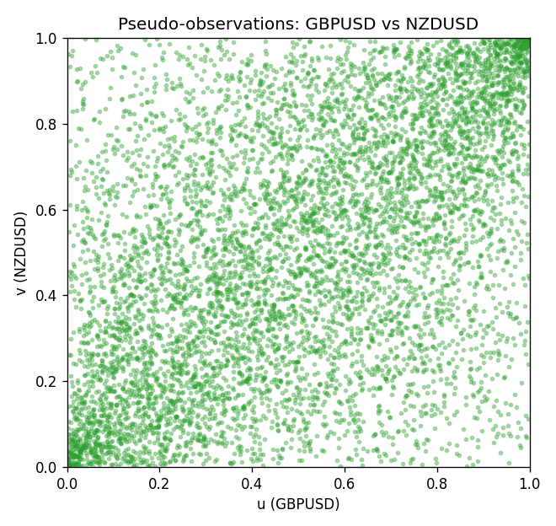

Data report
Every matched row is stored in the sibling Excel workbook named GBPUSD-NZDUSD_Copula_D1.xlsx, including u and v. Embedding all rows as a Word table is impractical; this file holds column summaries and the first and last 15 matched rows.
Columns: time, GBPUSD_open, NZDUSD_open, GBPUSD_high, NZDUSD_high, GBPUSD_low, NZDUSD_low, GBPUSD_close, NZDUSD_close, GBPUSD_tick_volume, NZDUSD_tick_volume, GBPUSD_spread, NZDUSD_spread, GBPUSD_real_volume, NZDUSD_real_volume, GBPUSD_log_return, NZDUSD_log_return, u, v
Column summaries (matched calculation rows)
column | count | mean | std | min | 25% | 50% | 75% | max
GBPUSD_open | 7203 | 1.5160351 | 0.21820856 | 1.06854 | 1.32502 | 1.51126 | 1.63163 | 2.1066
NZDUSD_open | 7203 | 0.65617721 | 0.10827592 | 0.3913 | 0.59107 | 0.6683 | 0.72469 | 0.88218
GBPUSD_high | 7203 | 1.5223294 | 0.21877071 | 1.08366 | 1.3298 | 1.51797 | 1.63833 | 2.1161
NZDUSD_high | 7203 | 0.66009189 | 0.10877133 | 0.3961 | 0.594565 | 0.67188 | 0.729235 | 0.88421
GBPUSD_low | 7203 | 1.5097156 | 0.21743942 | 1.03518 | 1.319525 | 1.50315 | 1.62431 | 2.0983
NZDUSD_low | 7203 | 0.65248767 | 0.1078698 | 0.3897 | 0.587935 | 0.66402 | 0.72082 | 0.87988
GBPUSD_close | 7203 | 1.5161019 | 0.21816437 | 1.06879 | 1.32515 | 1.51122 | 1.63196 | 2.1065
NZDUSD_close | 7203 | 0.65624807 | 0.10827144 | 0.3907 | 0.591395 | 0.6683 | 0.724915 | 0.8822
GBPUSD_tick_volume | 7203 | 94800.961 | 153533.35 | 62 | 9991 | 52873 | 91772.5 | 1273370
NZDUSD_tick_volume | 7203 | 68552.383 | 123030.52 | 16 | 5500.5 | 33815 | 58467.5 | 1127682
GBPUSD_spread | 7203 | 26.976121 | 19.194852 | 0 | 11 | 20 | 50 | 50
NZDUSD_spread | 7203 | 30.373178 | 25.676979 | 0 | 9 | 17 | 50 | 80
GBPUSD_real_volume | 7203 | 3.5551025e+09 | 8.4426509e+10 | 0 | 0 | 0 | 0 | 2.4038164e+12
NZDUSD_real_volume | 7203 | 1.6657093e+10 | 8.4881524e+10 | 0 | 0 | 0 | 0 | 2.705649e+12
GBPUSD_log_return | 7203 | -2.372e-05 | 0.00564203 | -0.08388241 | -0.00312422 | 3.221e-05 | 0.0031735 | 0.03112653
NZDUSD_log_return | 7203 | 5.29e-06 | 0.00764545 | -0.07027433 | -0.00426254 | 0.00021291 | 0.00457891 | 0.05966839
u | 7203 | 0.5 | 0.28865509 | 0.00013881 | 0.25006941 | 0.5 | 0.74993059 | 0.99986119
v | 7203 | 0.5 | 0.28865509 | 0.00013881 | 0.25006941 | 0.5 | 0.74993059 | 0.99986119
First 15 matched rows (selected columns)
time | GBPUSD_log_return | NZDUSD_log_return | u | v
1999-01-05 | -0.0028966287 | -0.0018597736 | 0.26582454 | 0.37388951
1999-01-06 | -0.00060452184 | 0.0020455609 | 0.44183787 | 0.61479733
1999-01-07 | -0.002118709 | 0.0062963171 | 0.32065519 | 0.82648529
1999-01-08 | -0.0058954193 | -0.00055396548 | 0.11785119 | 0.45197113
1999-01-11 | -0.0056851331 | 0.010290425 | 0.12479178 | 0.93017768
1999-01-12 | 0.0022657001 | -0.0053157489 | 0.68892282 | 0.20627429
1999-01-13 | 0.0091330396 | -0.0099742238 | 0.95474736 | 0.079261521
1999-01-14 | 0.0019376331 | -0.00018564931 | 0.66199334 | 0.47556913
1999-01-15 | -0.0017558204 | -0.00074294208 | 0.34827873 | 0.44128262
1999-01-18 | 0.0012112405 | -0.0018597736 | 0.60410883 | 0.37388951
1999-01-19 | 0.0018745281 | 0.0018597736 | 0.65616324 | 0.60369239
1999-01-20 | -0.0049053846 | 0.0040793678 | 0.15644087 | 0.72577735
1999-01-21 | 0.0031518998 | 0.0040627941 | 0.74819545 | 0.72459745
1999-01-22 | 0.0024781662 | -0.012051689 | 0.70419212 | 0.052887285
1999-01-25 | 0.0012066366 | -0.0035504102 | 0.60369239 | 0.28692393
Last 15 matched rows (selected columns)
time | GBPUSD_log_return | NZDUSD_log_return | u | v
2026-10-13 | 0.0036434319 | 0.0047326165 | 0.77776235 | 0.75805108
2026-10-14 | -0.0049164679 | -0.0037306483 | 0.15588562 | 0.27776235
2026-10-15 | 0.0065976411 | 0.0047634855 | 0.90352582 | 0.75957801
2026-10-16 | 0.0037592051 | 0.0057501001 | 0.78456413 | 0.80552471
2026-10-19 | -0.0017500314 | 0.0018917133 | 0.34938923 | 0.60646863
2026-10-20 | 0.0055923442 | 0.0037199341 | 0.87048862 | 0.70669073
2026-10-21 | 0.0012476328 | 0.0030923331 | 0.60688506 | 0.67559689
2026-10-22 | 0.00022396082 | -0.0033035227 | 0.51832315 | 0.29650194
2026-10-23 | -0.0021146949 | 0.0030929853 | 0.32121044 | 0.6757357
2026-10-26 | -0.0024340661 | -0.0028993932 | 0.29677957 | 0.31704609
2026-10-27 | -0.0023648393 | -0.00026399852 | 0.3019156 | 0.46904498
2026-10-28 | 0.0015771808 | -0.0097283914 | 0.63381455 | 0.084258745
2026-10-29 | 0.0035881935 | 0.00062190714 | 0.77554137 | 0.52623542
2026-10-30 | 0.0013450605 | 0.00019537668 | 0.61479733 | 0.49875069
2026-11-02 | 0.0010971256 | -0.0025962955 | 0.59466963 | 0.33231538

